3. Annual Rollover

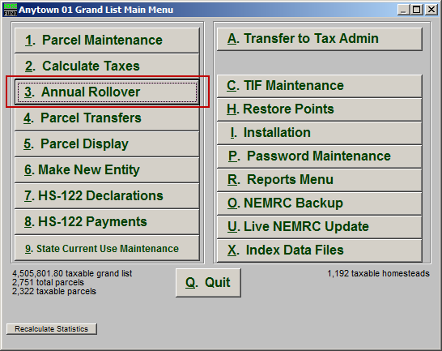
Click on “3. Annual Rollover” from the Main Menu and the following window will appear:

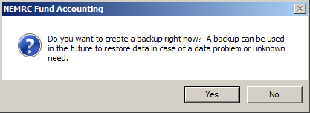
You should always choose to create a backup.
Annual Rollover

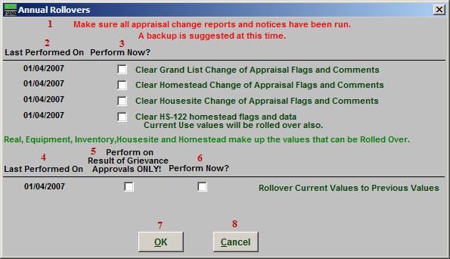
- Make sure all appraisal change reports and notices have been run: This notice is here to remind you to make sure that you have run all appraisal change reports/notices. This is because you will not be able to run those reports on the same data after you run the Annual Rollover.

- Last Performed On: This column shows the date that each Rollover was last run.

- Perform Now?: Check the box in this column to have the Rollover next to it take place.

- Last Performed On: This column shows the date that each Rollover was last run.

- Perform on Result of Grievance Approvals ONLY!: Check the box in this column to have the Rollover take place only on Parcels that have a Result of Grievance Approval.

- Perform Now?: Check the box in this row to have the Rollover next to it take place.

- OK: Click this button to continue with the Annual Rollover. All items checked as “Perform Now” will be run.

- Cancel: Click “Cancel” to cancel and return to the Main Menu.

